Body | Drum Kit | Part 1
Right-Left | Ride Bell
Clap | Snare Drum
Snap | Tom Tom
Chest | Kick
Note Value: |  | 1/8 (♪) | 1/8 (♪) | 1/8 (♪) | 1/8 (♪) | 1/8 (♪) | 1/8 (♪) | 1/8 (♪) | 1/8 (♪)
 |  | We have eight 1/8 notes (♪)

Rhythm Block for Part 1
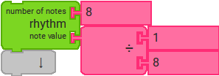 | The top number specifies how many. | For Part 1, we have the number 8 to specify a total of eight notes.
 | The bottom number specifies what kind. | For Part 1, we have 1/8 (with “8” in the bottom) for eighth notes.  The music symbol is ♪

Body | Drum Kit | Part 2
Right-Left | Ride Bell
Clap | Snare Drum
Snap | Tom Tom
Chest | Kick
Note Value: |  | 1/8 | 1/8 | 1/8 | 1/8 | 1/8 | 1/8 | 1/8 | 1/16 | 1/16
 |  | We have seven 1/8 notes; then two 1/16 notes

Rhythm Block(s) for Part 2: What values do we need? Is one rhythm block enough?
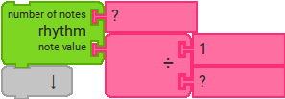  Is one rhythm block enough? | What values do we need to specify seven 1/8 notes? | My answer:
 | Then how do we add two 1/16 notes at the end? | My answer:

