Part 1 – 1st Half of Bread
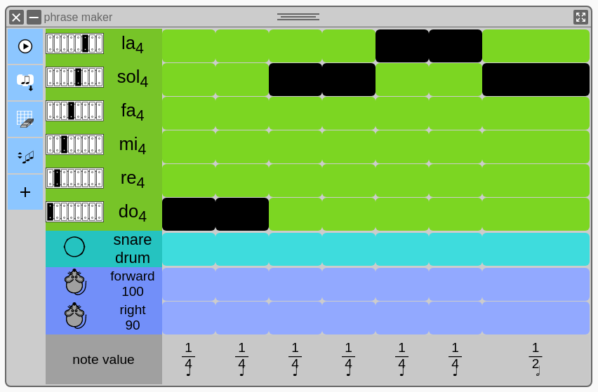

Part 2 – 2nd Half of Bread
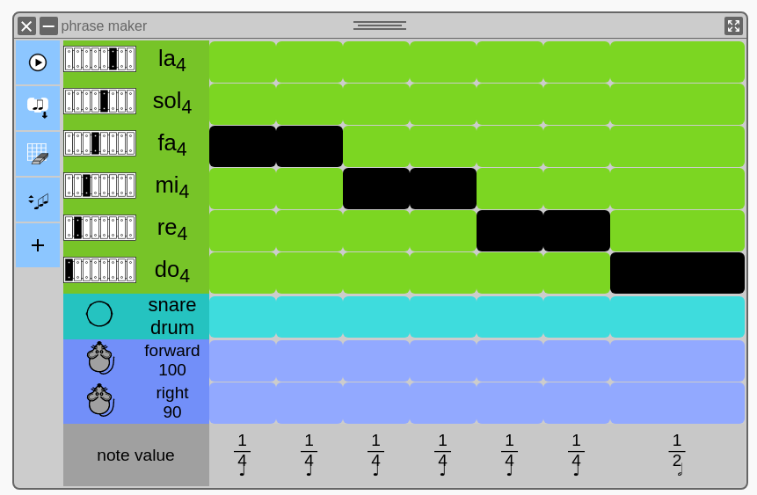

Part 3 – Peanut Butter and Jelly
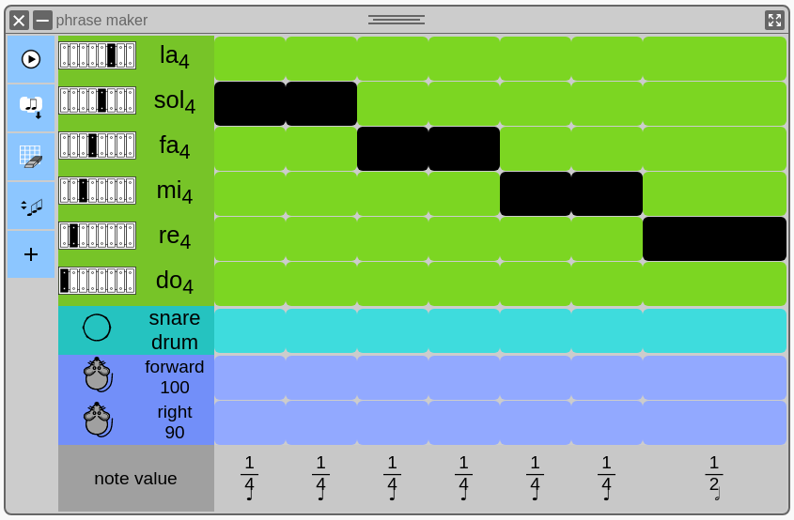

Play all of “Twinkle Twinkle”
Bread (1st and 2nd halves)
Peanut Butter and Jelly x2
Bread (1st and 2nd halves)

There you have it! Good job!

Let’s Figure it out with Music Blocks!
First, pull out a “Phrase Maker” block from the widget palette. Then add “Do” and “Fa”, both with octave “4”. It should look like this:

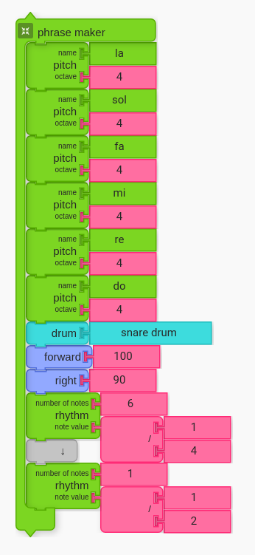
1. Illustration: Phrase Maker from Widgets Palette.

Transcribe “Twinkle Twinkle” with Phrase Maker
Next, fill in the Phrase Maker with exactly what you played on the first two pages. Save each of the parts as Action blocks.
Part 1 – Bread, 1st Half | Part 2 – Bread, 2nd Half | Part 3 – PB+J
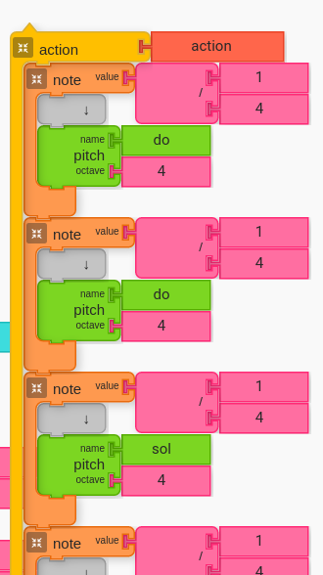 | 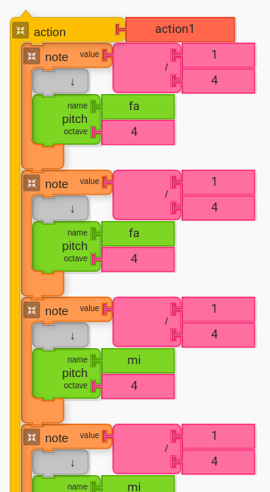 | 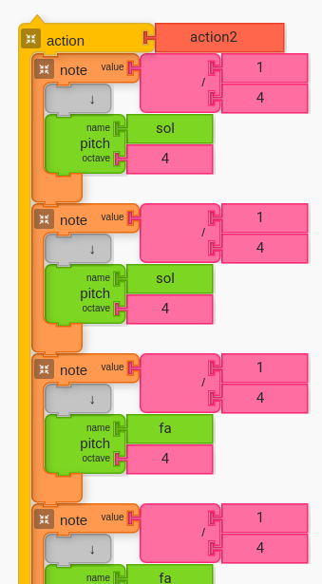

Put it all Together
Put everything together in order. It is fun and accurate to order everything like a sandwich, with bread on the outside and peanut butter and jelly on the inside.
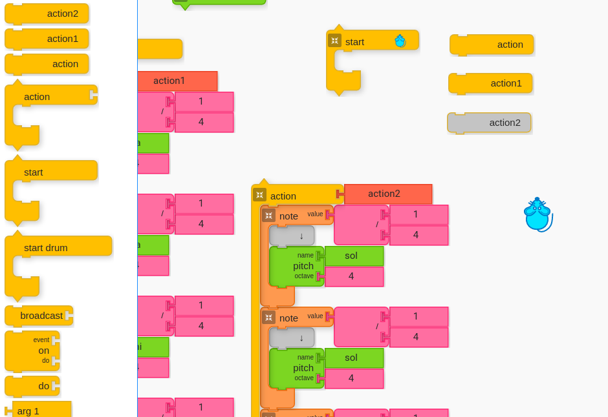Saved Action Blocks may look something like this. How do we put them in order to make “Twinkle Twinkle”? | 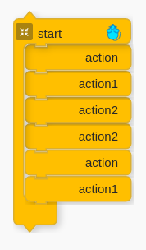You can order them like this. | 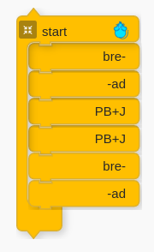Make a Peanut Butter and Jelly Sandwich!

Next Steps: Remix!
Change the pitches in the Action Blocks and make your own songs!

